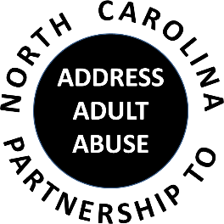
Triangle J Council of Government
4307 Emperor Blvd., Suite 110
Durham, NC
Conference Call # 1 888 204-5984 Access Code 9641989#
AGENDA
01/15/2020
9:30 Welcome, Introductions and Opening Comments – Nancy Warren
Review and approve Meeting Minutes – Laura Jett
Review and approve Treasurer’s Report – Pam Palmer
10:00 Program - NCPAAA is delighted to welcome Colin Austin, a lawyer in private practice with Hillsborough Wills & Trusts. Colin will address, "Preventing Elder Abuse through Strong Estate Planning." He will discuss determining capacity to sign, options under a financial Power of Attorney and health care decision making.

11:00 Break
11:15 Updates - NCPAAA Conference update – Shevel Mavins and Ann Elmore; Upcoming webinars; Updates from NAPSA, ACL and Elder Justice Coalition – Nancy Warren;
12:15 Member Updates and Wrap-up
Next NCP3A meeting March 18, 2020 – “Adult Services Roadmap”
12:30 Adjourn
SAVE THE DATE: NCP3A ANNUAL CONFERENCE MAY 20, 2020

