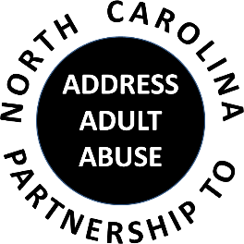
Triangle J Council of Governments
Area Agency on Aging
Guilford County Family Justice Center
201 S. Greene St. (parking deck at corner of Green and Washington)
Call In Number: 336-641-7026
March 15, 2017
AGENDA
9:30 Welcome, Introductions and Opening Comments – Chair
Review and approve minutes
Treasurer’s Report – Pam Palmer
10:00 Program: Catherine Johnson, Director, Guilford County Family Justice Center
11:00 BREAK
11:15 Committee Sessions:
Communications – Pam Palmer
Education – Kathryn Lanier
Advocacy – Nancy Warren
Awareness – John Maron and Stephanie Bias
Membership and Nominating - Kevin Robertson
12:00 Committee Updates
12:15 Member Updates and Wrap-up:
Review tasks and dates of next meeting
Other Announcements
12:30 Adjourn
NEXT MEETING: Annual Meeting, May 17; Judicial Center

