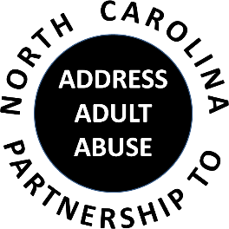
Triangle J Council of Governments
Area Agency on Aging
4307 Emperor Blvd # 110, Durham, NC 27703
Conferencing number: 1 888 204 5984 Access Code: 9641989#
November 16, 2016
AGENDA
9:30 Welcome and Opening Comments – Chair
Review and approve minutes
Treasurer’s Report – Pam Palmer
Introductions and Member Updates
10:00 Program: Legal Aid of NC’s Elder Abuse Project: Real Life Examples,
Angie Dorsey, Senior Managing Attorney
11:00 BREAK
11:15 Committee Sessions:
Communications -
Education – Kathryn Lanier
Advocacy – Nancy Warren
Awareness – John Maron and Stephanie Bias
Membership and Nominating - Kevin Robertson
12:00 Committee Updates
12:15 Wrap-up: Review tasks and dates of next meeting
NC Coalition on Aging Update
Other Announcements
12:30 Adjourn
NEXT MEETING: January 18, 2016; Triangle J Council of Governments

