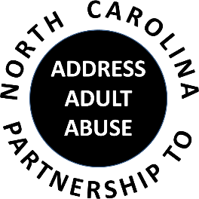
Triangle J Council of Governments
Area Agency on Aging
4307 Emperor Blvd # 110, Durham, NC 27703
Conferencing number: 1 888 204 5984 Access Code: 9641989#
January 18, 2017
AGENDA
9:30 Welcome and Opening Comments – Chair
Review and approve minutes
Treasurer’s Report – Pam Palmer
Introductions and Member Updates
10:00 Program: Elder Suicide
Stephen M. Marson, Ph.D. ACSW
11:00 BREAK
11:15 Committee Sessions:
Communications – Pam Palmer
Education – Kathryn Lanier
Advocacy – Nancy Warren
Awareness – John Maron and Stephanie Bias
Membership and Nominating - Kevin Robertson
12:00 Committee Updates
12:15 Wrap-up: Review tasks and dates of next meeting
NC Coalition on Aging Update: NCP3A Legislative Agenda Ballot
Other Announcements
12:30 Adjourn
NEXT MEETING: March 15, 2017; Guilford County Justice Center

