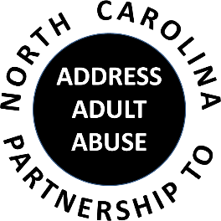

Triangle J Council of Governments
Area Agency on Aging
4307 Emperor Blvd. #110, Durham, NC 27703
Conference Call # 1 888 204-5984 Access Code 9641989#
September 20, 2017
AGENDA
9:30 Welcome, Introductions and Opening Comments – Joan Pellettier
Review and approve Minutes – Ty Whitaker
Review and approve Treasurer’s Report – Pam Palmer
10:00 Program: Kristine L. Sullivan, Senior Attorney, Disability Rights North Carolina

11:00 BREAK
11:15 Committee Sessions:
Communications – Pam Palmer
Education – Kathryn Lanier
Advocacy – Nancy Warren
Awareness – John Maron and Stephanie Bias
Membership and Nominating - Kevin Robertson
11:30 Committee Updates and Other Business
12:15 Member Updates and Wrap-up
12:30 Adjourn

NEXT MEETING: November 15, 2017; NC Judicial Center

