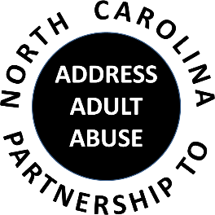

Triangle J Council of Governments
Area Agency on Aging
4307 Emperor Blvd. #110, Durham, NC 27703
Conference Call # 1 888 204-5984 Access Code 9641989#
July 18, 2018
AGENDA
9:30 Welcome, Introductions and Opening Comments – Nancy Warren
Review and approve Minutes – Laura Jett
Review and approve Treasurer’s Report – Pam Palmer
10:00 Program: Joyce Massey-Smith, Director, NC Division of Aging and Adult Services
11:00 BREAK
11:15 Committee Sessions/Reports:
Communications – Pam Palmer
Education – Madeline Masters and Shevel Mavins
Advocacy – Nancy Warren
Awareness – John Maron and Stephanie Bias
Membership and Nominating - Kevin Robertson
12:00 Member Updates and Wrap-up
12:30 Adjourn
NEXT GENERAL MEETING: September 19, 2018
NC Judicial Center, 901 Corporate Center Drive, Raleigh, NC

