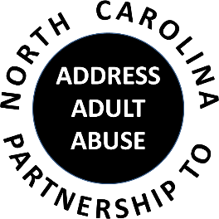

Triangle J Council of Governments
Area Agency on Aging
4307 Emperor Blvd. #110, Durham, NC 27703
Conference Call # 1 888 204-5984 Access Code 9641989#
March 21, 2018
AGENDA
9:30 Welcome, Introductions and Opening Comments – Joan Pellettier
Review and approve Minutes – Ty Whitaker
Review and approve Treasurer’s Report – Pam Palmer
10:00 Program: Krista Kretzschmar, CFP, Trust Fiduciary Services Manager, NCSECU Trust
Services
Stacy Ferrell, Trust Fiduciary Services Officer, NCSECU Estate Planning
11:00 BREAK
11:15 Committee Sessions/Reports:
Communications – Pam Palmer
Education – Madeline Masters and Shevel Mavins
Advocacy – Nancy Warren
Awareness – John Maron and Stephanie Bias
Membership and Nominating - Kevin Robertson
12:00 Member Updates and Wrap-up
12:30 Adjourn

NEXT MEETING: Annual Conference, May 16, 2018 at Wake Tech Southern Campus
Next Executive Committee Meeting: April 3, 2018

