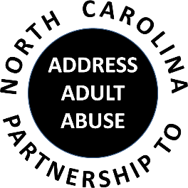
Triangle J Council of Government
4307 Emperor Blvd., Suite 110
Durham, NC
Conference Call # 1 888 204-5984 Access Code 9641989#
AGENDA
11/7/2018
9:30 Welcome, Introductions and Opening Comments – Nancy Warren
Review and approve Meeting Minutes – Laura Jett
Review and approve Treasurer’s Report – Pam Palmer
10:00 Program: Orange County SALT Program- Archie Daniel, Orange County Captain, Retired and Norma White, Director, Orange County Rural Alliance (OCRA)

11:00 BREAK
11:15 Committee Sessions/Reports:
We’re trying something different – after the break we’ll reconvene as a group and tackle a committee assignment altogether. This month we’ll be tackling “Advocacy” in preparation for the upcoming General Assembly long session. Look forward to some good discussion and ideas.
12:15 Member Updates and Wrap-up
12:30 Adjourn
NEXT GENERAL MEETING: Wednesday, January 16, 2019, 9:30-12:30 at Triangle J Council of Government, Durham, NC

SAVE THE DATE: NCP3A ANNUAL CONFERENCE MAY 15, 2019

