General Communication Tips  Speak in clear sentences. Use simple words and concepts. Break a complex idea down into smaller parts.  Use precise language with simple words. When possible, use words that relate to things you both can see. Avoid directional terms—right/left. Ask who, what, or where questions. When and how questions may be difficult to answer.  Speak directly; make eye contact if possible before speaking. Say the person’s name often.  Don’t use “baby–talk” or talk down to the person. Remember that adults—unless you are informed otherwise—can make their own decisions. Be aware of your voice tone and inflection.  Individuals may be eager to please and tell you what they think you want to hear. Be prepared to use a variety of questions: yes/no, either/or and open-ended questions.  Be patient; allow the person to take time as needed. It can be difficult for individuals to make quick decisions. Be encouraging, rather than correcting; don’t speak for the person.  Signs with visual cues can help individuals find their way around a facility or answer questions.  Use hand gestures and notes, if helpful.  Don’t pretend to understand if you’re having difficulty doing so. |  | North Carolina Coalition Against Sexual Assault  www.nccasa.org  919-871-1015  Carolina Institute for Developmental Disabilities  www.cidd.unc.edu  References  Centers for Disease Control and Prevention (2010). Behavioral Risk Factor Surveillance System.  Hingsburger, D. (2001). Sexuality and People with Developmental Disabilities. Mountville: Vida Publishing. |  | Sexual Violence and People with Intellectual/ Developmental Disabilities  - A factsheet with information for respecting and supporting individuals with IDD

Persons with disabilities in NC experience sexual assault at a rate 5 times higher than persons without disabilities  What do we know about violence about people with IDD?  Persons with disabilities in NC experience sexual assault at a rate 5 times higher than persons without disabilities.  80% of women and 60% of men with IDD have been sexually abused.  Sexual violence can be prevented.  What is a developmental disability (DD)?  DD means someone has limitations in three or more of the following areas: self–care, language, movement, self–direction, capacity for independent living, or economic self–sufficiency. The onset of DD is before age 22 and often includes intellectual disability. Examples are: autism spectrum disorder (ASD), Down syndrome, fragile X syndrome, cerebral palsy, or spina bifida. In North Carolina, DD includes disability caused by a traumatic brain injury at any age. | What is an intellectual disability (ID)?  ID means someone has limitations in intellectual functioning (reasoning, learning, solving problems) and in adaptive behavior (the range of everyday social and practical skills). This type of disability originates before the age of 18.  When you are supporting a survivor with IDD…  - Acknowledge the individual’s emotional state. You seem upset today...You must be proud...That must be frightening. Such statements validate the individual’s experience, and help to build trust.  - Behavior is one way of communicating. Pay attention to non–verbal cues, over–compliance, resistance, and body language.  - Use more than one way to give information. Include stories, graphics, icons, and other tools.  - Some individuals may feel comfortable pacing, need a small space, or prefer a quiet place away from distractions.  - Use verbal or visual cues when changing topics. If the individual is having difficulty understanding a question, try asking it in a different way. | 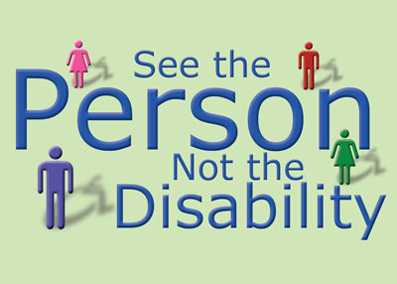  Using Person-First Language  - Put the person first. Person with a disability instead of disabled person.  - Say wheelchair user, rather than wheelchair bound. The wheelchair enables the person to get around and participate in society; it’s liberating, not confining.  - It’s okay to use idiomatic expressions when talking to people with disabilities. See you later, to a person who is blind is acceptable.  - Avoid disempowering words: victim, sufferer.  - Avoid outdated terms like handicapped, crippled and retarded.

